DS 413/613 LAB Webscraping for tables

Instructions: Email an Rmarkdown file and a Word file for the problems given below. Each file should show all required R coding and associated out put.

Installations and libraries needed are as follows:

install.packages("rvest")

library(rvest) library(tidyverse) library(dplyr)

**1**) Using the web address <https://en.wikipedia.org/wiki/ITF_Rankings> and the R coding structure presented in class to web scrape the following table found on the page.

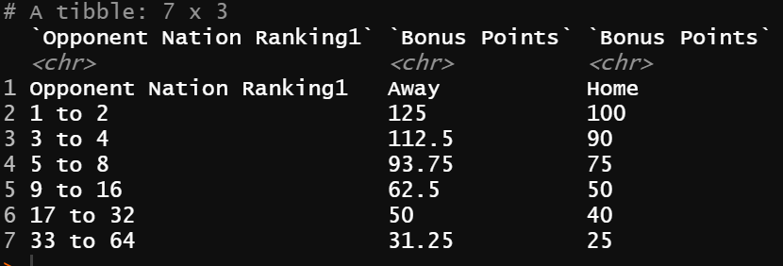

**2)** Using the web address <https://www.mlb.com/stats/2018> and the R coding structure presented in class, web scrape the table found on the page.

**3**) Use and show R code to find the average number of hits for all players in the table from number 2

**4**) Use and show R code to produce a boxplot for the number of hits (use tidyverse/ggplot coding). Use the data table from number 2.

**5)** Use and show dplyr coding to determine which player had the greatest number of strikeouts using the data table from number 2.

**6)** Use and show dplyr coding to show the batting averages for Washington Nationals players and Colorado Rockies players using the data table from number 2